Name(s):
Address:
E-Mail: Phone #:
Years Served Onboard: Total Years in the Navy:
Rate/Rank (Ret Rank): Position:
Plank Owner: Decom Crew: Division:
Number & Name of Guests:

Registration Fee $ 50

09/21/21 Arrival Day
09/22/22 USS Midway Tour: (member pays for own ticket) Guest Count:__ ___

Buffet Dinner (Vivo Italiano) $140 x __ = $
(Buffet is $99 per person plus a 40.75% tax, S/C and Hotel Fees)

09/23/23 Bay Cruise 2 Hour Full Harbor Tour $ 39 x _____ = $

Plated Banquet Dinner – Grilled Pacific Salmon $129 x __ = $
(Dinner is $91 per person plus a 40.75% Tax, S/C and Hotel Fees)

Plated Banquet Dinner –Lemon Sage Chicken $131 x = $
(Dinner is $93 per person plus a 40.75% Tax, S/C and Hotel Fees)

09/24/26 Depart – See you in 2028! Donation: Anything will Help!! $
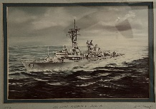
$150+ Donation
15 Available
Mounted Pastel Drawing
Drawn by Beth Haizlip
Wife of Gunnery Officer LCDR Ken Haizlip 80-84

Total Payment: = $

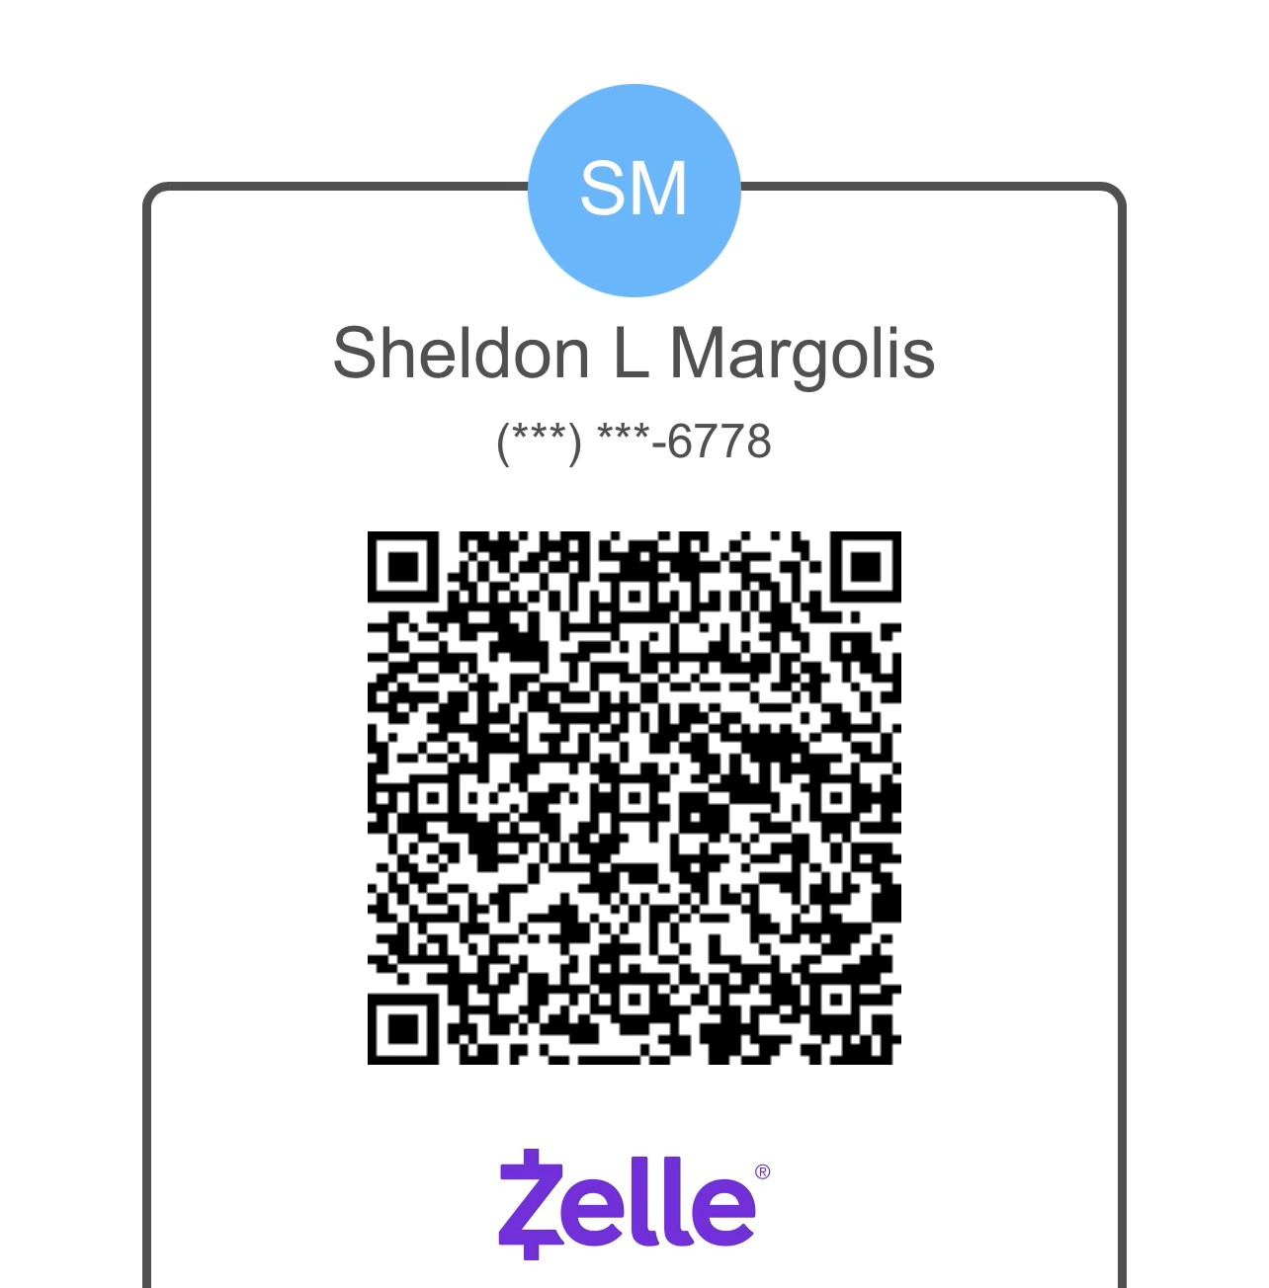
Make Check Payable to: USS Lynde McCormick (DDG 8) All Hands Association

Pay Via Venmo - @Sheldon-Margolis Mail Check & Form to:
Pay Via PayPal - @SheldonDDG8 Shel Margolis
Pay Via Zelle – (858)774-6778 2241 Caminito Preciosa Sur
La Jolla, CA 92037

Hotel Reservations Link: https://book.passkey.com/go/USSLyndeMcCormick
Hotel Reservation by Phone: (800) 996-3426
Mention you are part of the USS Lynde McCormick All Hands Association
Group Rate Code: 09152026USS
Reservation Cut-Off Date is 24 August 2026
Wyndham San Diego Bayside - 1355 North Harbor Dr. San Diego, CA 92101

